NOTICE OF COMPLETE APPLICATION AND PUBLIC MEETING

TO INFORM THE PUBLIC OF A ZONING BY-LAW AMENDMENT

TAKE NOTICE that the Council for The Corporation of the Municipality of Powassan has received a complete application under Sections 34 and 36 of the Planning Act, R.S.O. 1990, c.P. 13 as amended, to inform the public of a proposed Zoning By-law Amendment.

The public meeting is being held for the application described below to enable interested members of the public to understand and comment on a proposed Zoning By-law Amendment.

DATE AND LOCATION OF PUBLIC MEETING

File #: 2022-03
Date: Tuesday, April 18, 2023
Time: 6:30 pm
Location: Municipality of Powassan – 250 Clark Street

DETAILS OF THE ZONING BY-LAW AMENDMENT

The purpose and effect of the proposed Zoning By-Law Amendment is to amend the Restricted Area (Zoning) By-Law No. 2003-38, as amended, for the lands described as Lot 18, Concession 16 (Civic Address: 505 Peever Line), in the Municipality of Powassan.

The application, if approved, would remove the Holding (-H) symbol from the subject lands. The Holding (-H) Symbol was applied as part of a previous amendment to the Zoning By-law no. 2023-01 to permit a ‘Rural Event Venue’ use on the subject lands. The Holding (-H) Symbol is to be lifted once the municipality is satisfied that acceptable emergency vehicle access is provided for the ‘Rural Event Venue’ use. Tacoma Engineers has completed a review of the existing bridge crossing and confirmed it is structurally adequate to support the local fire department’s water tanker truck.

ADDITIONAL INFORMATION AND MAP OF LAND SUBJECT TO THE APPLICATION

A key map showing the land to which the proposed amendment applies is provided with this notice. The purpose of this meeting is to ensure that sufficient information is made available to enable the public to generally understand the applicant’s proposed Zoning By-law Amendment. Any person who participates in the meeting shall be afforded an opportunity to make representations in respect of the application. A conceptual site plan is available for review at the Municipal Office.

If a person or public body does not make written submissions to the Municipality of Powassan before the proposed By-law is passed, the person or public body is not entitled to appeal the decision of the Municipality of Powassan to the Ontario Land Tribunal.

If a person or public body does not make written submissions to the Municipality of Powassan before the proposed By-law is passed, the person or public body may not be added as a party to the hearing of an appeal before the Ontario Land Tribunal unless, in the opinion of the Tribunal, there are reasonable grounds to do so.

If you wish to be notified of the decision of the Council for the Corporation of the Municipality of Powassan in respect to the proposed Zoning By-law Amendment, you must submit a written request (with forwarding addresses) to the Clerk of the Municipality of Powassan at P.O. Box 250, 250 Clark Street, Powassan, Ontario, P0H 1Z0.

Additional information regarding the proposed amendment is available to the public for inspection at the Municipality of Powassan Municipal Office located at 250 Clark Street on Monday to Friday, between the hours of 8:30 a.m. and 4:30 p.m. please call (705) 724-2813.

Mailing Date of this Notice: March 24, 2023

Kimberly Bester, Deputy-Clerk
Municipality of Powassan
kbester@powassan.net

Location Map

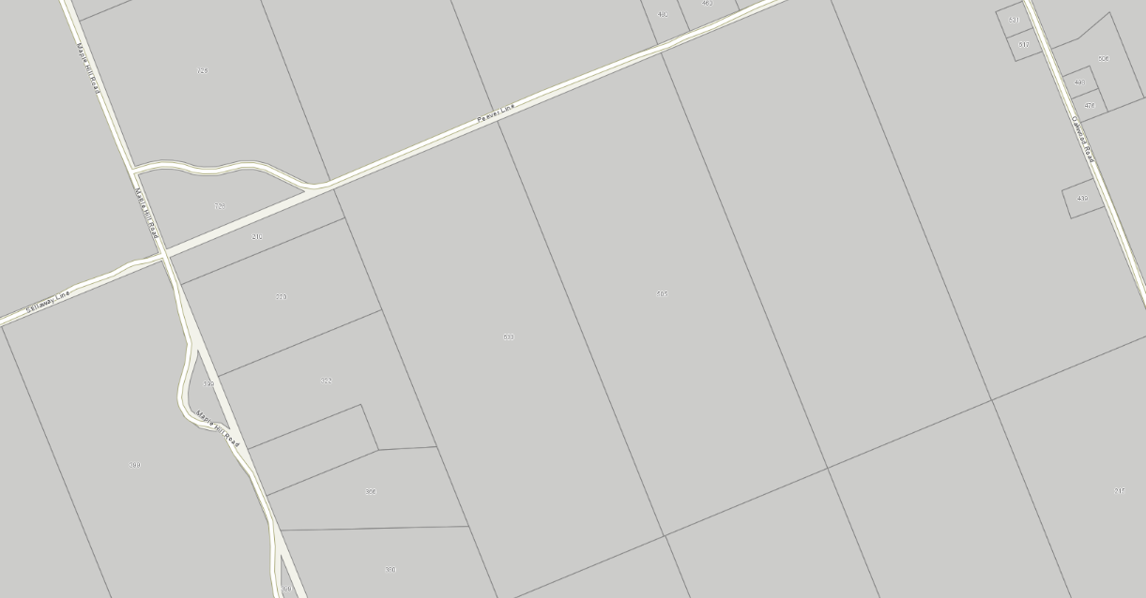

Subject Property
505 Peever Line

N

